

**Artificial Intelligence and Data Science Department.**

OS / Even Sem 2021-22 / Experiment 11.

**___________________________________________________**

YASH SARANG.

47 / D6AD.

EXPERIMENT - 11.

Page Replacement Policies.

**___________________________________________________**

**Aim:** Implementing Various page replacement policies: FIFO, Optimal, LRU.

**___________________________________________________**

**Theory:**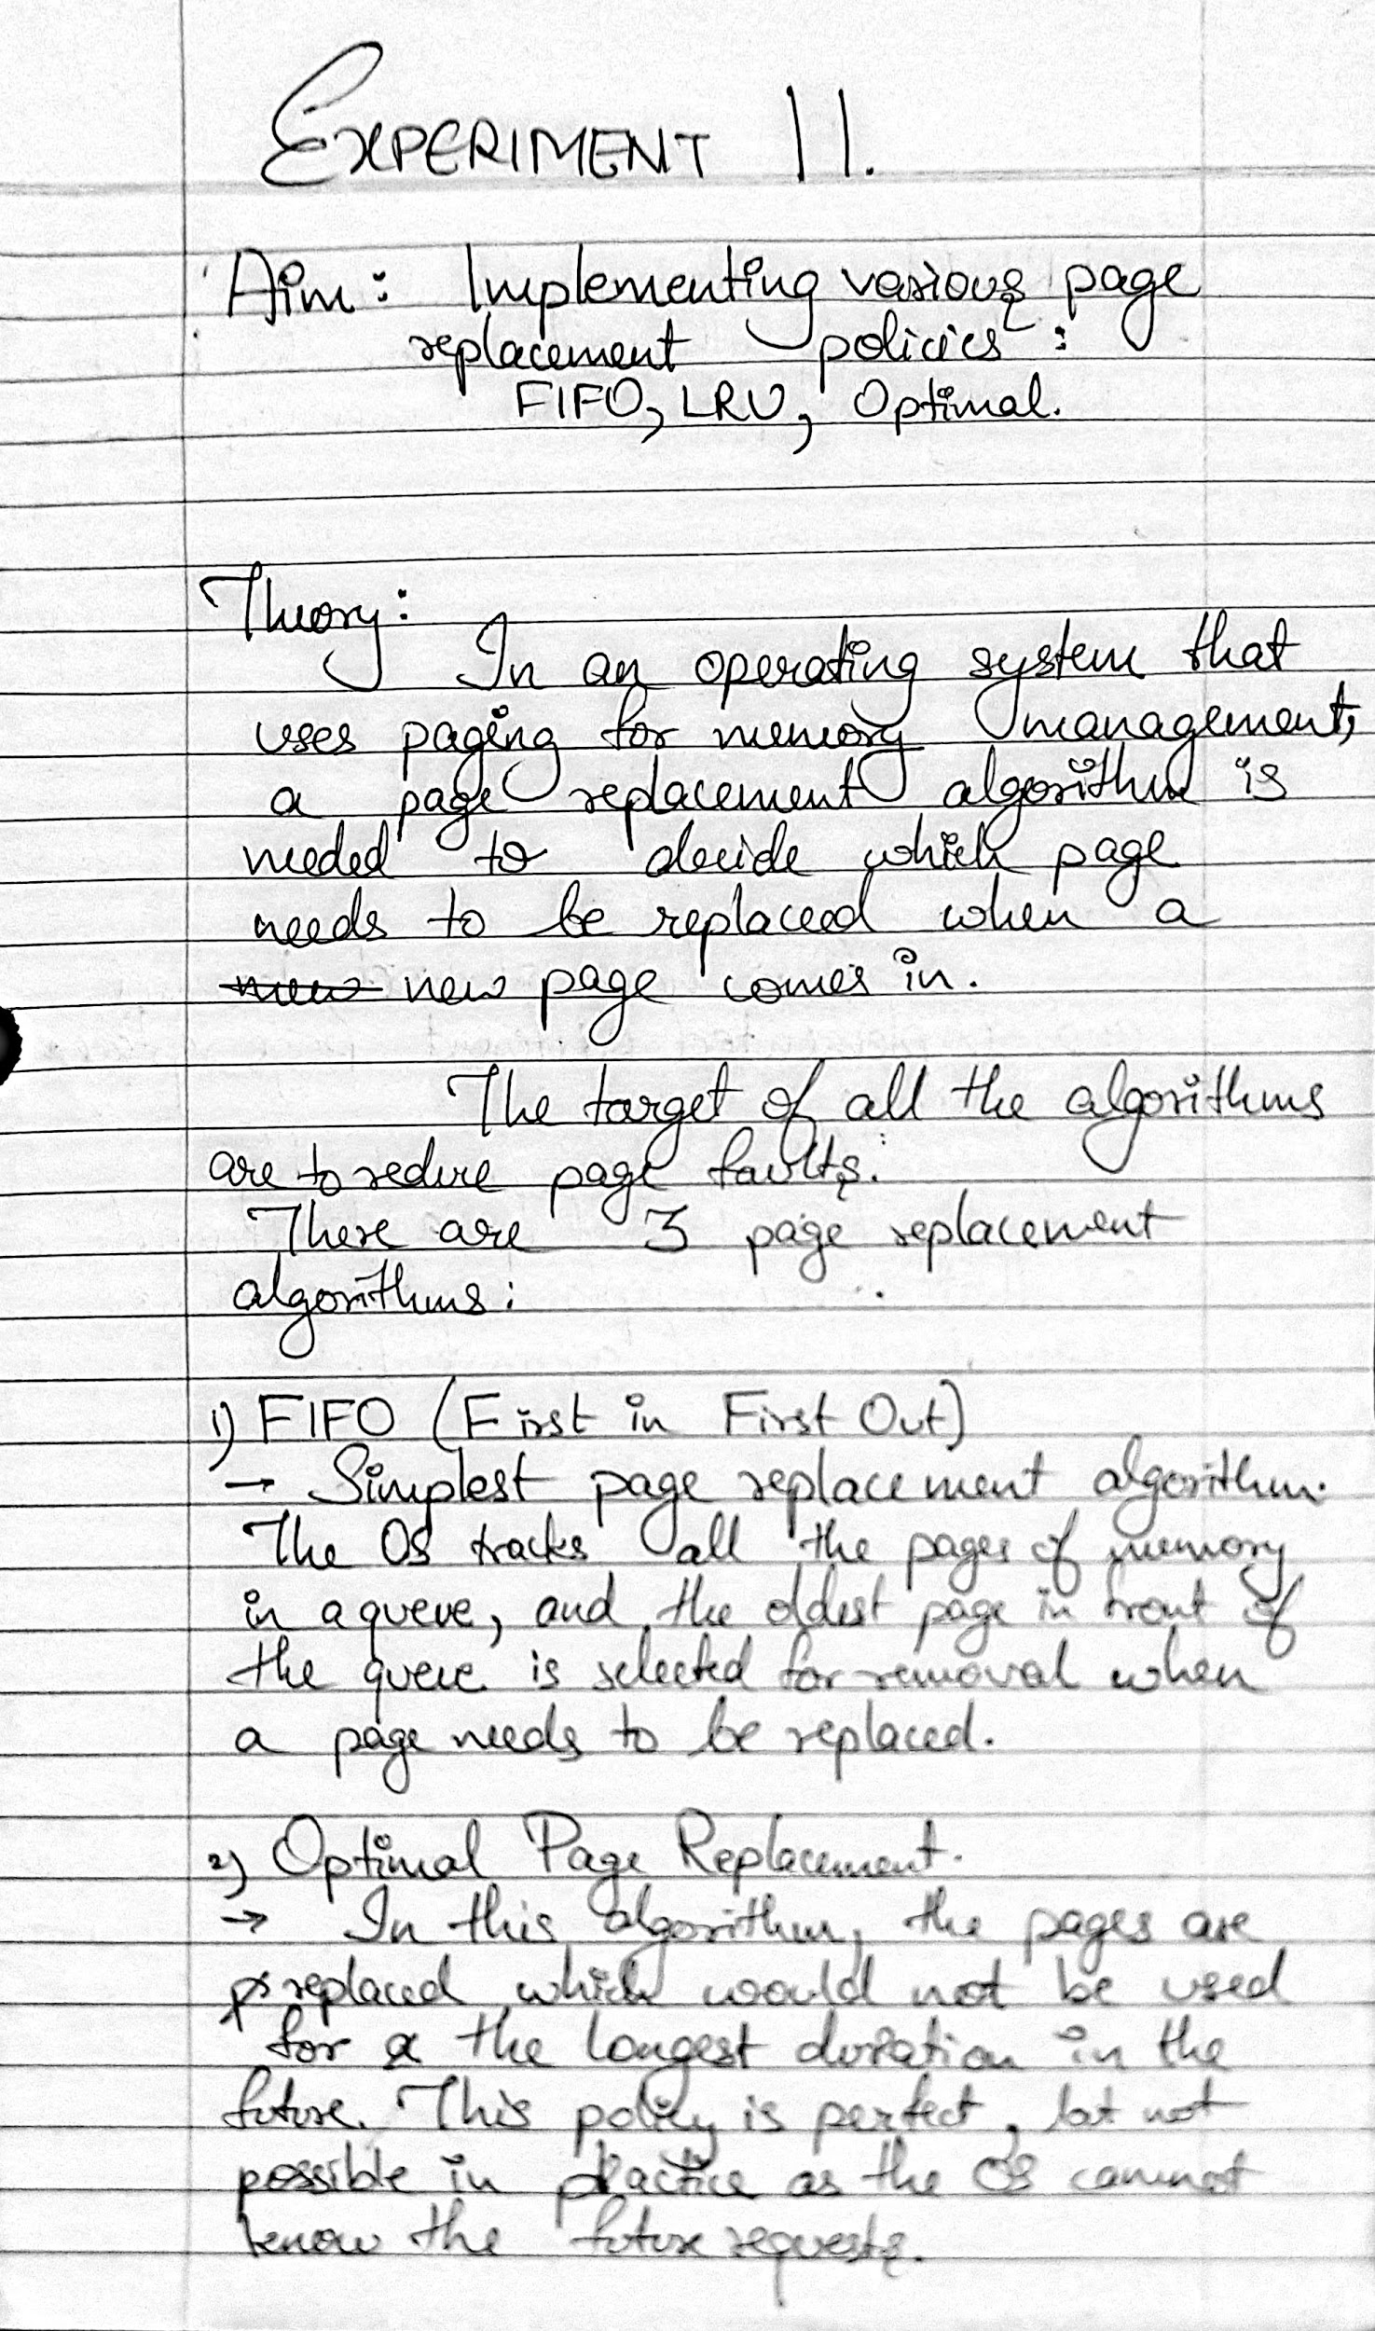



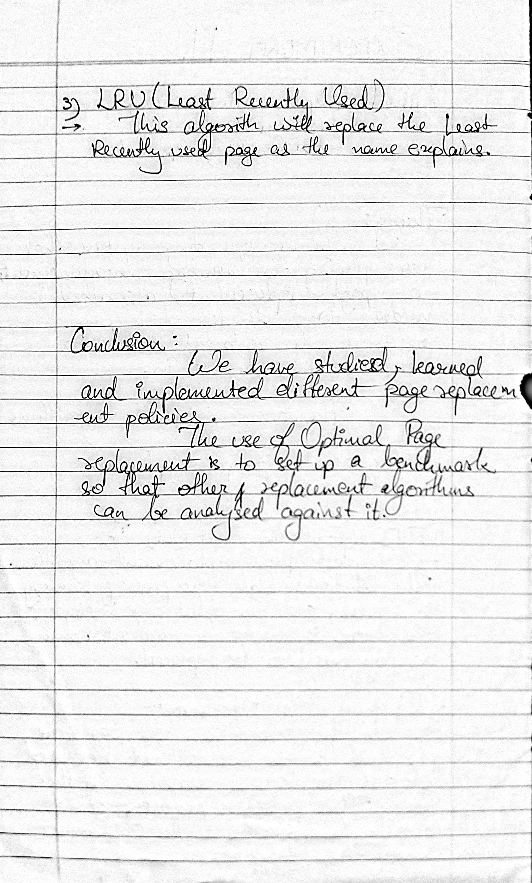

**___________________________________________________**

**Code:**

1. **FIFO**

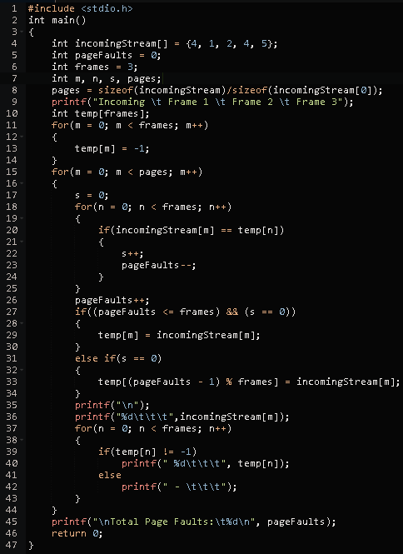

**Output:**

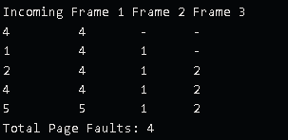

1. **LRU**

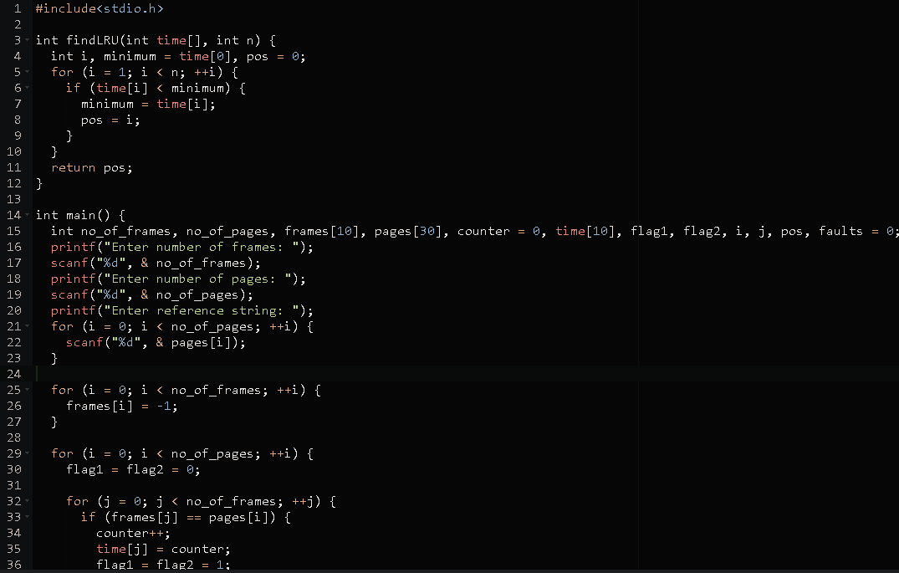

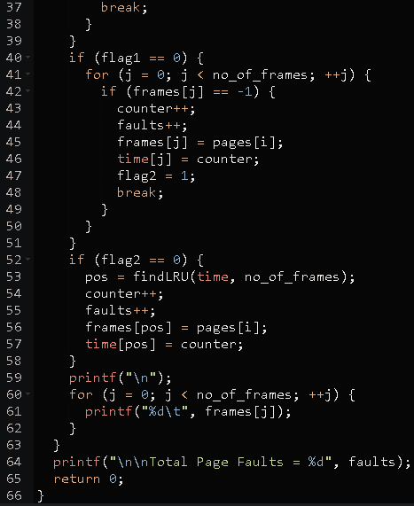

**Output:**

***Enter number of frames: 3***

***Enter number of pages: 6***

***Enter reference string: 5 7 5 6 7 3***

***5 -1 -1***

***5 7 -1***

***5 7 -1***

***5 7 6***

***5 7 6***

***3 7 6***

***Total Page Faults = 4***

**___________________________________________________**

**Conclusion:-**



**___________________________________________________**